Database Project Proposal

This database will be implemented for a small ice cream shop that is expanding into numerous new locations. With the growth, the company needs to start keeping better track of its finances. To accomplish this task, the company needs to monitor each store, employee, and instate a customer loyalty system. The company also wants a more consistent method to track its supply of ice cream and materials, such as ingredients, cups, and spoons.

Each store is undefined by an unique store number. The company would also like to track each store’s sales and the city they are located in. This information will help the company determine the amount of taxes each store owes.

The company wants to monitor employee efficiency. The company recognizes three different types of employees; general managers, clerical workers, and hourly employees. Regardless of the classification an employee falls under, they would like to know the name, social security number, ID number, phone number, date of birth, and address. For general managers, the company also wants to know the store number, salary, and the amount of remaining vacation days. For clerical workers, they also want to know the salary, title, non-disclosure agreement and the amount of remaining vacation. For hourly employees, they also want to know the wage and the number of hours worked per pay period.

The company has their own production facilities that supply ice cream to each store, so that taste of ice cream is consistent no matter which branch a customer purchases their ice cream from. The stores makes order to the production facilities. The orders are tracked by a order number. In addition to the order number, the store keeps track of the date order, the date the order should be complete, and flavor. The production facilities is identified by a facility number, flavors in stock, and the materials in stock.

Finally, the company wants to instate a customer loyalty program. For the loyalty program, each customer is given a loyalty number. Through the card, they would like to track their favorite flavor, the total visits, and their name.

Hourly employees need to use the database to clock their hours.

General managers need to use the database to input sales numbers, check the number of remaining vacation days, verify hours worked by hourly employees and to produce orders for the production facilities to carry out.

Clerical workers need to use the database to check the number of remaining vacation days, fill orders for their stores, add new staff members, verify non-disclosure agreement status of clerical workers and check stock of flavors and materials.

The entity sets for this database are:

* Stores
* Employees
* General Managers
* Clerical Workers
* Hourly Employees
* Order
* Production Facilities
* Customer

The operations to be performed to maintain this database are:

* Enter the sales information for every store every day. This helps insure that every store is profitable
* Update remaining vacation days for general managers and clerical workers every day.
* Update number of hours worked every day.
* Enter date ordered and date due for newly placed orders.
* Update flavor stock and materials stock every day.
* Update the customers total visit after every visit.
* Hourly workers are responsible for adding a new customer to the customer loyalty program
* Clerical workers are responsible for adding a new employee when an employee is hired.

20 queries that could be asked of the database:

1. How many plastic spoons did the general manager at store 2 order on 02/06/2018?
2. What production facility fulfills store 3s orders?
3. What are the sales at the store where hourly worker 14 works?
4. List the hourly workers that work at the store where the customer with the loyalty id 24 shops?
5. Which customer has the highest total visits?
6. Who is the general manager of the hourly worker with the eid 25?
7. What is the favorite flavor of the customer with the customer loyalty number 36?
8. Which customers have greater than 50 total visits?
9. Who is/are the ice cream maker(s) at the production facility that fulfilled flavor order number 12 and what are their phone numbers?
10. How much stock of chocolate ice cream is maintained by the clerical worker with the eid 20?
11. How much chocolate ice cream did the stores order from the production facility with the facility number 1?
12. How much stock of strawberry ice cream is present at production facility number 10?
13. What is the flavor and how much stock is remaining from 04/15/2018 flavor order?
14. When was the material order placed by general manager with the eid 33?
15. Find all clerical workers in production facility number 3 and whos NDA_Status is yes.
16. Find all material orders due on 04/30/2018.
17. How much of customer loyalty number 28 favorite flavor was last ordered by store number 1?
18. What is the wage of all hourly workers at store number 4?
19. At what store did hourly works have the most hours worked?
20. List all items that expire on 04/21/2018.
21. When do all flavor orders that were ordered by store 3 expire?
22. What is the highest salary for facility number 2.
23. List all customers whose favorite flavor is vanilla.

ERD:

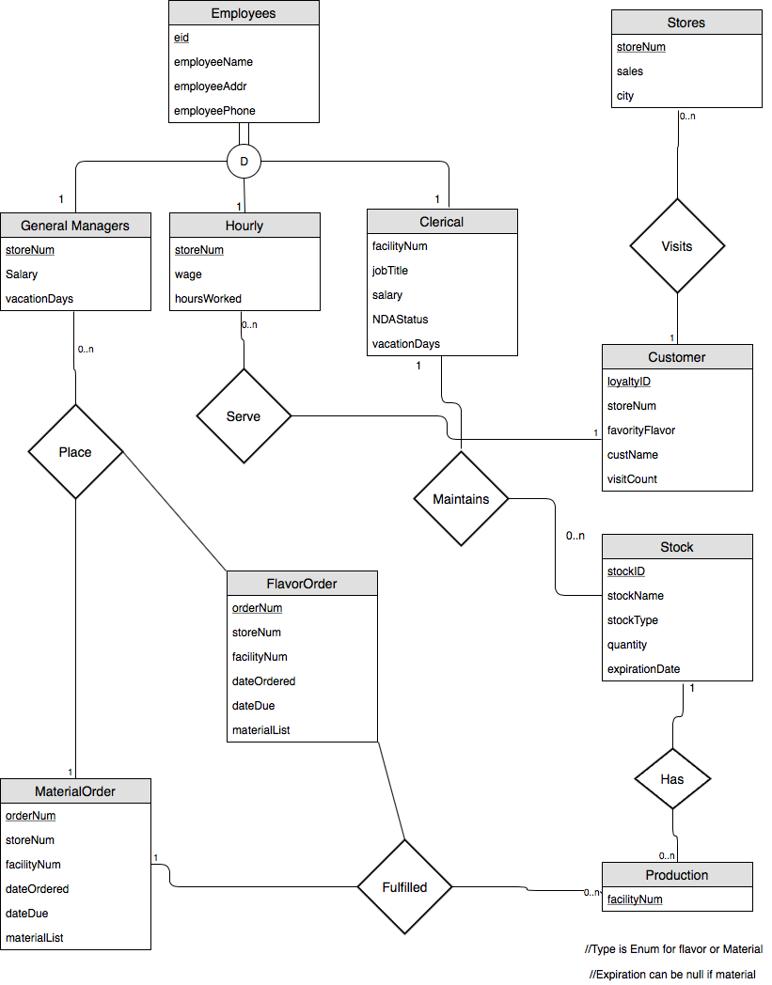

Relational Models:

|  |  |  |
| --- | --- | --- |
| **Entity** | **Attribute** | **Domain** |
| Employees | eid  (primary key) | Auto-Incrementing integer values in the range 0001-999999999. |
|  | employeeName | A String in first name last name format |
|  | employeeAddress | A string in the format (St. number St. name St. type Optional APT/suite number, City, state, zip) 999 W Franklin Street, Richmond VA, 23220 as an example. |
|  | employeePhone | A string in the format XXX-XXX-XXXX - 804-123-4567 |
| General Managers | eid  (foreign key) | Auto-Incrementing integer values in the range 0001-999999999. |
|  | storeNum | Integers in the range 0001-9999 |
|  | salary | Decimal values in the range 0.00-99999999.99, represents the yearly income |
|  | vactationDays | Integers in the range of 00-30, resets every year |
| Hourly Employee | eid  (foreign key) | Auto-Incrementing integer values in the range 0001-999999999. |
|  | storeNum | Integers in the range 0001-9999 |
|  | wage | Floating point number in the range of 7.25-22.00. represents a per hour wage. |
|  | hoursWorked | Floating point number in the range of 0.00-99999.99. represents how much a worker has worked during that pay period. |
| Clerical Worker | eid  (foreign key) | Auto-Incrementing integer values in the range 0001-999999999. |
|  | facilityNum | Integers in the range 01-99 |
|  | jobTitle | String that represents the title of the worker |
|  | salary | Decimal values in the range 0.00-99999999.99, represents the yearly income |
|  | NDAStatus | ENUM value that depends on the individuals NDA status (yes or no) |
|  | vacationDays | Integers in the range of 00-30, resets every year |
| FlavorOrder | orderNum  (primary key) | Auto-Incrementing integer values in the range 0001-999999999999. |
|  | storeNum | Integers in the range 0001-9999 |
|  | facilityNum | Integers in the range 0001-9999 |
|  | dateOrdered | Represents a date in this format: XX/XX/XXXX; the first XX is in the range 01-12, the second XX is in the range of 01-31, and the XXXX is in the range 2000-9999 |
|  | dateDue | Represents a date in this format: XX/XX/XXXX; the first XX is in the range 01-12, the second XX is in the range of 01-31, and the XXXX is in the range 2000-9999 |
|  | flavorList | A flavor from a set of flavors |
| MaterialOrder | orderNum  (primary key) | Auto-Incrementing integer values in the range 0001-999999999999. |
|  | storeNum | Integers in the range 0001-9999 |
|  | facilityNum | Integers in the range 0001-9999 |
|  | dateOrdered | Represents a date in this format: XX/XX/XXXX; the first XX is in the range 01-12, the second XX is in the range of 01-31, and the XXXX is in the range 2000-9999 |
|  | dateDue | Represents a date in this format: XX/XX/XXXX; the first XX is in the range 01-12, the second XX is in the range of 01-31, and the XXXX is in the range 2000-9999 |
|  | MaterialList | A materials from a set of materials |
| Stores | storeNum  (primary key) | Auto-Incrementing integer values in the range 0001-9999. Indicates the store’s unique ID number |
|  | sales | Floating point number with no range but cannot be negative. Must only possess two decimal places. I.E. 11,023.22 is legal, 11.023.2 is not. |
|  | city | A string that must always capitalize the first letter but has no other constraints I.E. Richmond not richmond. |
| Customers | loyaltyNum  (primary key) | Auto-Incrementing integer values in the range 0001-999999999. |
|  | storeNum | Integer values in the range 0001-9999. |
|  | FavoriteFlavor | A flavor from a set of flavors |
|  | custName | A String in first name last name format |
|  | visitCount | Decimal in the range 0001-9999 |
| Production | facilityNum | Auto-Incrementing integer values in the range 01-99.  Indicates the production facility’s unique ID number |
| Stock | stockID  (primary key) | Decimal in the range 000000000000-999999999999 |
|  | name | A one word string that represents the name of the flavor or material in sock. |
|  | type | A type from a set of type  (material or flavor) |
|  | quantity | Integers in the range 0001-9999. |
|  | expirationDate | Represents a date in this format: XX/XX/XXXX; the first XX is in the range 01-12, the second XX is in the range of 01-31, and the XXXX is in the range 2000-9999 |

Functionality of all relationships:

|  |  |  |
| --- | --- | --- |
| **Relationship** | **Functionality** | **Justification** |
| Place | one-to-many | The general manager can place many orders, but an order only is placed by one general manager |
| Serves | one-to-many | The hourly employee serves many customers, however, the customer is only served by one employee |
| Visits | many-to-one | The customer visits only one store, but a store can have many visits from one customer. |
| Maintains | one-to-many | The clerical worker maintains many stock items, but each stock item is maintained by one clerical |
| Has | one-to-many | A stock item belongs to one facility, but a production facility can have multiple stock items. |
| Fulfilled | one-to-many | An order goes to only one production facility, however, a production facility can have many orders. |

Normalization of the relations using BCNF/4NF:

**Employees** (eid, employeeName, employeeAddr, employeePhone)

Primary Key: eid

Functional Dependencies: employeeName → employeeAddr, employeePhone

Normal Form: 5NF

**General Managers** (eid, storeNum, salary, vacationDays)

Candidate Keys: eid

Primary Key: eid, storeNum

Functional Dependencies: none

Normal Form: 5NF

**Hourly Employees** (eid, storeNum, wage, hourWorked)

Primary Key: eid

Functional Dependencies: eid → storeNum, wage, hourWorked

Normal Form: 5NF

**Clerical Workers** (eid, facilityNum, jobTitle, salary, NDAStatus, vacationDays)

Primary Key: eid

Functional Dependencies: eid → facilityNum, jobTitle, salary, NDAStatus, vacationDays

Normal Form: 5NF

**FlavorOrder** (orderNum, storeNum, dateOrdered, dateDue, flavorList)

Primary Key: orderNum

Functional Dependencies: orderNum → dateOrdered, dateDue, flavorList

Normal Form: 5NF

**MaterialOrder** (orderNum, storeNum, dateOrdered, dateDue, materialList)

Primary Key: orderNum

Functional Dependencies: orderNum → dateOrdered, dateDue, materialList

Normal Form: 5NF

**Production** (facilityNum)

Primary Key: facilityNum

Functional Dependencies: none

Normal Form: 5NF

**Stock** (stockID, name, type, quantity, expirationDate)

Primary Key: stockID

Functional Dependencies: expirationDate → type

       name → type, quantity

Normal Form: 5NF

**Customer** (loyaltyNum, storeNum, favoriteFlavor, name, visitCount)

Primary Key: loyaltyNum

Functional Dependencies: loyaltyNum → favoriteFlavor, name, visitCount

Normal Form: 5NF

**Stores** (storeNum, sales, city)

Candidate Keys: storeNum

Primary Key: storeNum

Functional Dependencies: storeNum → sales, city

Normal Form: 5NF

Sample Data:

**General Manager**

|  |  |  |  |  |  |  |
| --- | --- | --- | --- | --- | --- | --- |
| eid | employeeName | employeeAddr | employeePhone | storeNum | salary | vacationDays |
| 3453 | Jon Doe | 134 W Franklin Street | 123-456-7898 | 6 | 35000 | 10 |
| 2785 | Sam Johnson | 456 E Broad Street | 739-456-7898 | 9 | 45000 | 7 |

**Hourly Employee**

|  |  |  |  |  |  |  |
| --- | --- | --- | --- | --- | --- | --- |
| eid | employeeName | employeeAddr | employeePhone | storeNum | wage | hoursWorked |
| 6737 | Jake Jackson | 345 W Franklin Street | 452-348-3847 | 1 | 9.00 | 20 |
| 7346 | Molly Smith | 100 E Broad Street | 487-274-2837 | 8 | 10.00 | 20 |

**Clerical Workers**

|  |  |  |  |  |  |  |  |  |
| --- | --- | --- | --- | --- | --- | --- | --- | --- |
| eid | employeeName | employeeAddr | employeePhone | facilityNul | title | salary | NDAStatus | vacationDays |
| 4728 | Ally Williams | 455 W Franklin Street | 123-324-5432 | 1 | Accountant | 50000 | True | 10 |
| 1234 | Robert Brown | 323 E Broad Street | 686-455-3455 | 7 | Packer | 30000 | Fale | 9 |

**FlavorOrder**

|  |  |  |  |  |  |
| --- | --- | --- | --- | --- | --- |
| orderNum | storeNum | facilityNum | dateOrdered | dueDate | flavorList |
| 2736 | 1 | 1 | 03/01/2018 | 03/08/2018 | Chocolate |
| 4837 | 3 | 2 | 03/07/2018 | 03/14/2018 | Strawberry |

**MaterialOrder**

|  |  |  |  |  |  |
| --- | --- | --- | --- | --- | --- |
| orderNum | storeNum | facilityNum | dateOrdered | dueDate | materialList |
| 1234 | 2 | 1 | 04/01/2018 | 04/15/2018 | Plastic Spoon |
| 3928 | 4 | 2 | 04/07/2018 | 04/23/2018 | Large Cone |

**Production**

|  |
| --- |
| Facility_Number |
| 1 |
| 5 |

**Stock**

|  |  |  |  |  |
| --- | --- | --- | --- | --- |
| StockID | name | type | quatity | Expiration_Date |
| 1 | Chocolate | Flavor | 2 | 06/30/2018 |
| 2 | Spoons | Material | 4 | Null |

**Customer**

|  |  |  |  |  |
| --- | --- | --- | --- | --- |
| loyaltyNum | storeNum | favoriteFlavor | custName | visitCount |
| 3648 | 1 | Chocolate | Josh Jones | 19 |
| 4294 | 3 | Vanilla | Jennifer Pitt | 67 |

**Stores**

|  |  |  |
| --- | --- | --- |
| storeNum | sales | city |
| 7 | 11,200.20 | Richmond |
| 10 | 15,934.56 | Midlothian |